Machine Learning, Individual HW 3: Structured Prediction

Xiao Tan tanx2@oregonstate.edu

1. Structured Perceptron
   1. First just use two feature templates: ⟨t, t′⟩ and ⟨t, w⟩. Training unaveraged perceptron for 5 epochs. Which epoch gives the best error rates on dev?

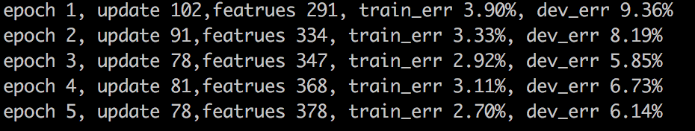

Training unaveraged perceptron for 5 epochs, I got the results as the picture shows upon. The best error rates will be 5.85%, while epoch 3.

* 1. Now implement the averaged perceptron. What is the new best error rate on dev?

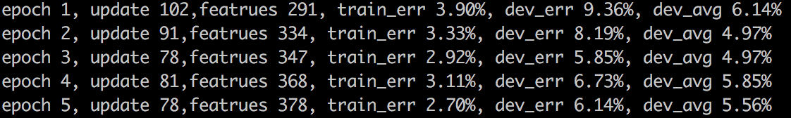

Here are the results of averaged perceptron for 5 epochs, I got the best error rate as 4.97%

in epoch 2 and epoch 3.

* 1. How much slower is averaged perceptron? Compare the time between unaveraged and averaged version.

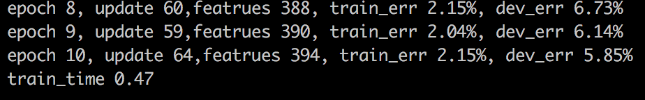



Picture 1 and 2 show the time used by unaveraged and averaged perception for 10 epoch. Averaged perceptron will cost more time than unaveraged, but not too much.

* 1. Plot a single plot that includes four curves: {unaveraged, averaged} x {train err, dev err}. What did you find from this plot?

Because unaveraged and averaged train err will be the same, so we can only see 3 curves on the plot. The result is showed in following graph.



* 1. Explain why we replaced all one-count and zero-count words by <unk>.

Because training data won’t have every word we may test in the future, replaced all one-count and zero-count words by <unk> will make this model can handle unknown words, no matter what words it is, just treat those low frequency words or unknown words as <unk>.

1. Feature Engineering (based on averaged perceptron)